ENGR101 Assignment 2

#### Name: Niels Clayton Student ID: 300437590

**Core 1:**

INP

STO 90

HLT

**Core 2:**

The program from core one tells LMC to take the input provided (INP), then to store it in memory slot 90 (STO 90) after which it halts the program (HLT).

**Completion 1:**

INP

STO 7

INP

STO 8

INP

STO 9

HLT

I chose locations 7,8, and 9 because they are after the HLT command and therefor wont over write or break the code.

**Challenge 1:**

Input the number, then subtract the value 999 from it and then store it in the memory, when outputted, add 999 to it again and then output.

INP

SUB A

STO 90

ADD A

OUT

HLT

DAT A 999

**Core 3:**

|  |  |  |  |  |  |
| --- | --- | --- | --- | --- | --- |
| **Line Executed** | **PgC** | **Opcode** | **Input** | **“Result”** | **Memory Cell 15** |
| Before Execution Starts | 0 | --- | 30 | 000 | 000 |
| INP | 0 | 901 | 30 | 30 | 000 |
| STO 15 | 1 | 315 | 30 | 30 | 30 |
| INP | 2 | 901 | 33 | 33 | 30 |
| ADD 15 | 3 | 115 | 33 | 63 | 30 |
| OUT | 4 | 902 | 33 | 63 | 30 |
| HLT | 5 | 000 | 33 | 63 | 30 |

**Core 4:**

INP

STO 15

INP

STO 16

SUB 15

OUT

HLT

**Completion 2:**

No it will not give the desired result as it is doing OUT = IN3 – (IN1 + IN2)

INP

STO 99

INP

ADD 99

STO 99

INP

STO 98

LDA 99

SUB 98

OUT

HLT

**Core 5:**

LDA A

STO 10

LDA B

STO 11

LDA C

STO 12

HLT

DAT A 1

DAT B 2

DAT C 3

The program is now longer so the variables must be stored in a new location to stop them overwriting the code.

**Core 6:**

INP

STO A

INP

STO B

LDA 32

ADD 39

OUT

HLT

DAT B 39

DAT A 32

**Core 7:**

LDA 90

ADD A

STO 90

BRA 0

DAT A 1

**Completion 3:**

LDA A

STO 98

LDA B

STO 99

SUB 98

OUT

STO 99

BRP 4

HLT

DAT A 1

DAT B 5

**Challenge 2:**

LDA A

STO 98

LDA B

STO 97

INP

STO 99

INP

SUB 99

BRZ 10

BRA 13

LDA 98

OUT

HLT

LDA 97

OUT

HLT

DAT A 1

DAT B 0

**Core 8:**

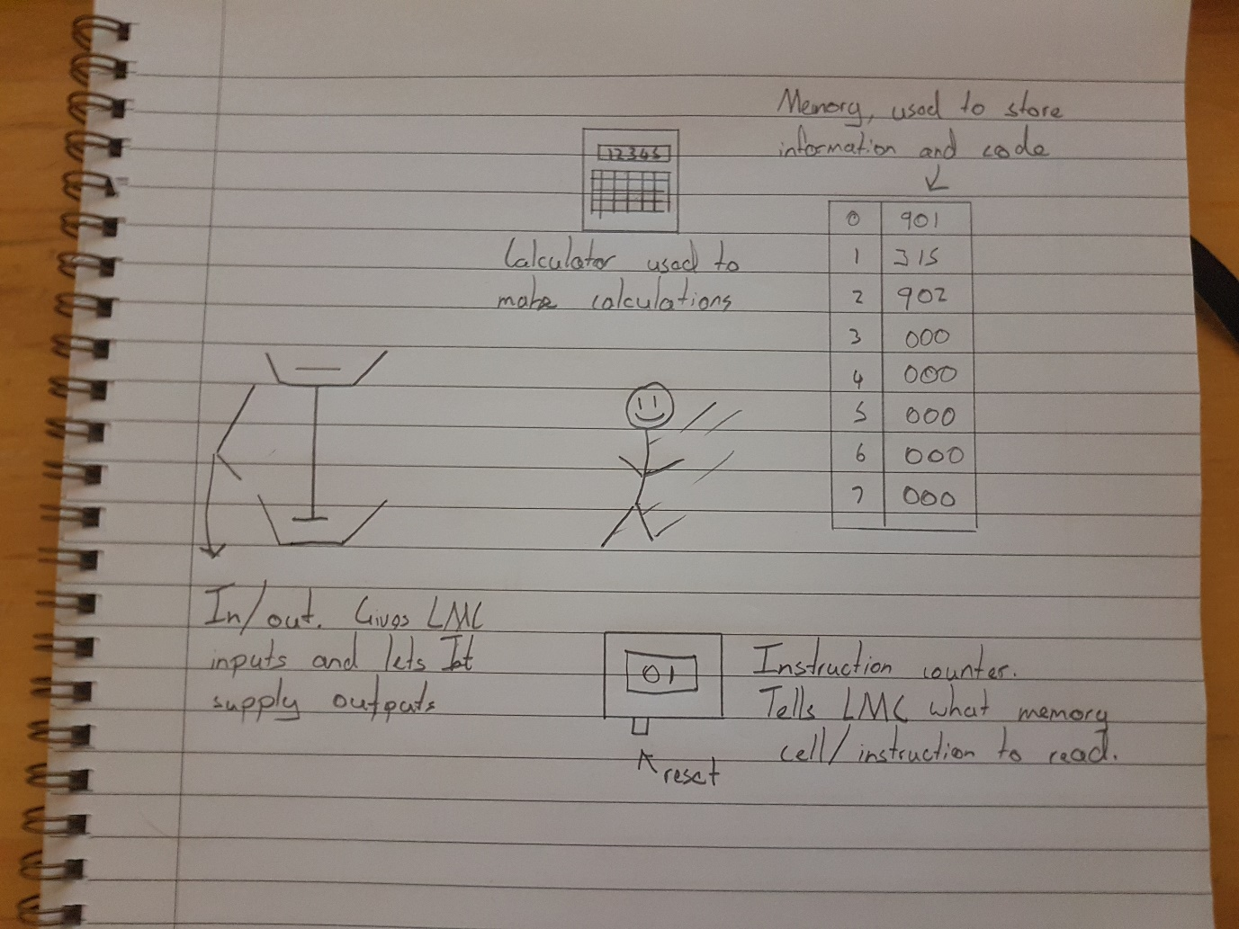

**Challenge 3 (Bonus Marks Only):**

LDA Z

STO 16

LDA C

STO 99

LDA 3

SUB F

STO 3

LDA 16

SUB F

STO 16

BRZ 12

BRA 2

HLT

DAT C 999

DAT F 1

DAT Z 83